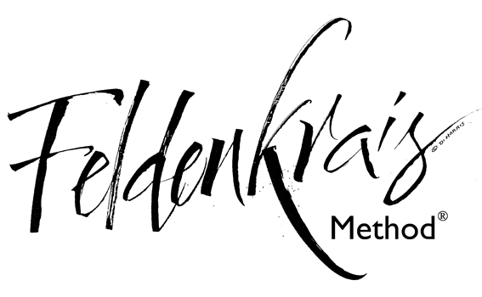
Based on learning to move in more effective ways, The Feldenkrais Method helps anyone who would like to refine physical and mental performance, and improve their quality of life. The one-on-one lessons are designed to meet your specific needs, and may help you improve how you move, think, feel, sense and act. Comfort, ease, and quality of movement are key. Please wear loose, comfortable clothing – trousers or leggings are more suitable than a skirt.

Holysym special price $45/hour

Please contact Bridget Auchmuty Musters on 021-526827 for an appointment

